Title: | Certificate II in Information Technology
Area: | Technology & Enterprise
Unit Code: | (ICAU2006B)
Lesson No. | 01 Op Computer Packages
Title: | A1 Poster Creation

Notes:
Teacher: | Mr Peter Faulks

Contact:
Timeline: | Eight Hours
Due Date | By 3:30pm Friday Week 3 Term 1

Task 01 Poster Creation using a range of software.
CTIT Today Pty Ltd have asked you to create a more up to date and sophisticated poster for their four poster college collection, your task is to present one poster (from those shown below) in one of the four categories that enhances and promotes the use of computing in Colleges, TAFE or University places of study. The quality required is high professional.

They require the following:
- A proposal in Microsoft word confirming your ability to create the poster and an estimate of the cost based upon your hourly rate.
- All art work to be in Adobe Illustrator
- All enhanced text and graphics to be Photoshop.
- The Final document to be created as a .pdf using Adobe Acrobat.

You are to supply working documents showing your preparation of graphics using Photoshop, background image effects using Illustrator and final preparation is to be as an Acrobat pdf file. You may use other software to prepare work but you may not use images from the internet.

The company need to replace all four posters, A sample of the original child like poor quality posters is included, select one to work on, update and improve this to a level suitable for adult students. If you are capable you can attempt two or more posters.

Deadline and due date for this poster is 3:30pm Friday, Week 3 Term 1 Failure to submit by this time will mean loss of contract and you will be given another poster to make.

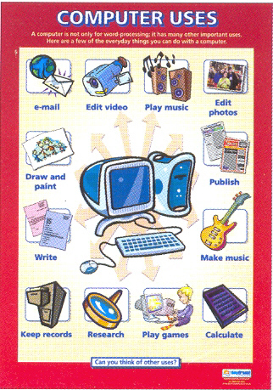 | 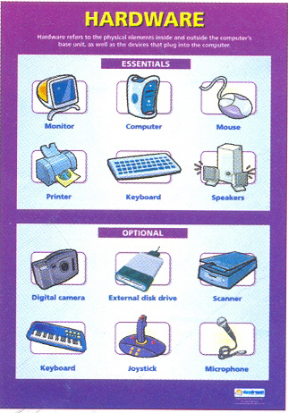
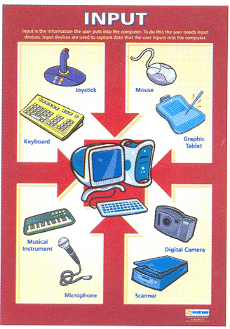 | 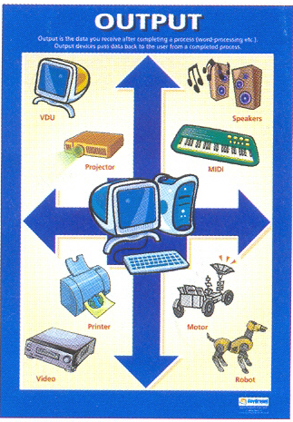

Note you may need to enlarge the images to get a better idea of what is required.

